Introduction to micro-pipetting

Goal for this lab:
Master micropipetting technique.

Introduction
One of the most important skills you will need in this course is your ability to use a micropipettor. Micropipettors are used to make accurate measurements of extremely small volumes—from one milliliter down to one microliter (1 mL to 1 μL). Most of what we do in molecular biology involves manipulating volumes of liquid in this range. If you learn to do it accurately now, your experiments will go much more smoothly later.

Micropipettors
These are precision scientific instruments, and must be treated with respect. The pipettor is used to draw liquid up into a cheap disposable tip. The three pipettors you will use take up and deliver liquids in the volume range from ~0.5 μL to 1.0 mL. Your instructor will show you how to use this device. Read and follow these guidelines to maintain the accuracy and precision of your pipettors.
Rotate the volume adjustor to the desired setting. Note the change in plunger length as the volume changes. Be sure to properly locate the decimal point when reading the volume setting. (Your instructors will demonstrate.)
You have three sizes of pipets in this lab: LTS20s, which can measure between 1 μL and 20 μL; LTS200s, which can measure between 21 μL and 200 μL; and LTS1000s, which can measure between 200 μL and 1000 μL (1 mL).
There are three numbers on the display of each pipettor. Look at the top of the pipet to see which one you are holding, then look at the display. The numbers represent volumes as shown below. The color change represents crossing the decimal place or changing units.
L 20 |  |  | L 200 |  |  | L 1000
1 | 10 | µL | 1 | 100 | µL | 1 | 1000 | µL = 1.0 mL
0 | 1 | µL | 0 | 10 | µL | 0 | 100 | µL
0 | 0.1 | µL = 100 nL | 0 | 1 | µL | 0 | 1 | µL
Firmly seat a proper-sized tip on the end of the micropipettor. The tips boxes are color-coded to match the label on the plunger.
When withdrawing or expelling fluid, always hold the tube firmly between your thumb and forefinger, keeping it nearly at eye level to observe the change in the fluid level in the pipet tip. Do not pipet with the tube in the test tube rack or have another person hold the tube while you are pipetting.
Hold the tube in your hand during each manipulation. Open the top of the tube by flipping up the tab with your thumb. During manipulations, grasp the tube body (rather than the lid), to provide greater control and to avoid contamination of the mouth of the tube.
For best control, grasp the micropipettor in your palm and wrap your fingers around the barrel; work the plunger (piston) with the thumb. Hold the micropipettor almost vertical when filling it.
Notice the friction “stops” on the two-position plunger with your thumb. Depressing to the first stop measures the desired volume. Depressing to the second stop introduces an additional volume of air to blow out any solution remaining in the tip.

To withdraw the sample from a reagent tube:
- Depress the plunger to first stop and hold it in this position. Dip the tip into the solution to be pipetted, and draw fluid into the tip by gradually releasing the plunger. Be sure that the tip remains in the solution while you are releasing the plunger.
- Slide the pipet tip out along the inside of the reagent tube to dislodge any excess droplets adhering to the outside of the tip. To avoid future pipetting errors, learn to recognize the approximate levels to which particular volumes fill the pipet tip.
- If you notice air space at the end of the tip or air bubbles within the sample in the tip, carefully expel the sample back into its supply tube. Collect the sample at the bottom of the tube by pulsing it in a microcentrifuge.

To expel the sample into a reaction tube:
- Touch the tip of the pipet to the inside wall near the bottom of the reaction tube into which the sample will be emptied. This creates a capillary effect that helps draw fluid out of the tip.
- Slowly depress the plunger to the first stop to expel the sample. Depress to second stop to blow out the last bit of fluid. Hold the plunger in the depressed position.
- Slide the pipet out of the reagent tube with the measurement plunger depressed, to avoid sucking any liquid back into the tip.
Use the ejector button (located at the back and different from the plunger) to remove the tip into a waste container.

Important pipettor don’ts:
- Never rotate the volume adjustor beyond the upper or lower range of the pipet.
- Never use the micropipettor without the tip in place; this could ruin the piston. Pipettors use disposable plastic tips. Every molecular biology lab circulates its own version of the story of the not-too-bright grad student who did not use a tip. Do not be this student!
- Never invert or lay the micropipettor down with a filled tip; fluid will run back into the piston.
- Never let the plunger snap back after withdrawing or expelling fluid; smooth motions are the key to success.
- Never immerse the barrel of the micropipettor in fluid. Only the disposable tip touches the liquid.
- Never reuse a tip. Tips are pretty cheap (about $0.59 per rack). The risk of cross contaminating your solutions is too great to get tricky with tips. Just use a new one every time unless there is no possibility of cross contamination—like if you are pipetting the same solution into multiple empty tubes.

Measurement Repeatability
An essential property of good science is that an experiment gives the same results even in different hands. Repeated measurements of the same thing should give the same value, no matter who makes the measurement.

Pipette calibration
Figure out what each of these volumes of water should weigh, and which pipet should be used to dispense that volume:
µL |  | mL | weight (g) |  | weight (mg) | pipet
1000 | = |  |  | =
100 | = |  |  | =
10 | = |  |  | =
Put a weigh boat on the balance pan, and zero the balance.
Dispense the appropriate volume of water onto the pan.
Re-zero the balance, and check the next pipette.
Repeat until all the pipettes have been checked.
Check discrepancies with your instructor. It’s better to pay to have your pipette calibrated now than to get inaccurate experimental results all summer long.

Repeatability
Cut a sheet of Parafilm long enough to cover the table provided.
In each space, pipette 5µL of bromothymol staining solution onto the parafilm. Think about whether you need to change tips between droplets.
Check to make sure that all drops are the same size. You can easily remove a drop and re-do it if necessary.

Accuracy
Using a new tip each time, add the requisite volume (in µL) of sodium phosphate dibasic to each droplet of stain. (Why do you suppose you must change tips?)
Add the requisite volume of sodium phosphate monobasic to each stain-dibasic droplet.
If you do not have a color gradient from yellow, through green, to blue, you have made an error somewhere.
Check that each mixed drop is the same as the others.

Why does this work?
Bromothymol blue is a pH indicator. It has a multiple conjugated ring structures (6-carbon rings with alternating single and double bonds) that give it a plane of electrons that interact readily with light. Slight changes in acidity alter the configuration of these rings and change the particular wavelengths it absorbs.
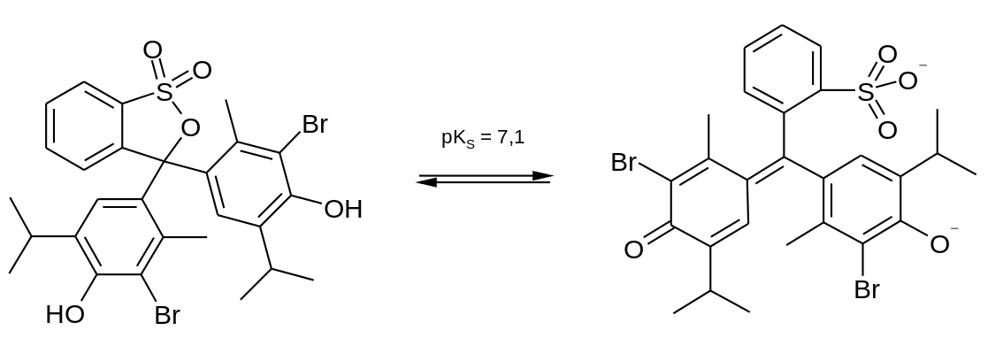
By Steffen 962 - Own work, Public Domain,
https://commons.wikimedia.org/w/index.php?curid=15179368

Sodium phosphate buffer works like this:
Sodium phosphate monobasic  (one univalent metal) |  |  |  | Dihydrogen phosphate ion  Hydrogen donor  acidic
NaH₂PO₄ | ↔ | Na⁺ | + | H₂PO₄–

Sodium phosphate dibasic  (two univalent metal) |  |  |  | Hydrogen phosphate ion  Hydrogen acceptor  basic
Na₂HPO₄ | ↔ | 2Na⁺ | + | HPO₄^{2–}

Dihydrogen phosphate ion  Hydrogen donor  acidic |  |  |  | Hydrogen phosphate ion  Hydrogen acceptor  basic
H₂PO₄– | ↔ | H⁺ | + | HPO₄^{2–}

If you add H⁺, the equilibrium shifts toward dihydrogen phosphate
If you add OH–, the equilibrium shifts toward hydrogen phosphate
But the concentration of H⁺ stays the same. (∴ a buffer!)

 |  |  |  |  | H₃PO₄
 |  |  |  |  | ↑↓ | pKa′ | 2.12
monobasic | NaH₂PO₄ | ↔ | Na⁺ | + | H₂PO₄–
 |  |  |  |  | ↑↓ | pKa′′ | 7.21
dibasic | Na₂HPO₄ | ↔ | 2Na⁺ | + | HPO₄^{2–}
 |  |  |  |  | ↑↓ | pKa′′′ | 12.32
tribasic | Na₃PO₄ | ↔ | 3Na⁺ |  | PO₄^{3–}

