KLP61F RNAi protocol (this is 2 pages long)
You will need:
- Happy GFP-tubulin-expressing S2 cells (you’ve been maintaining these!)

- Double-stranded RNAi complementary to the KLP61F gene (you made this in week 4!)

- Complete Schneider’s Medium (what you’ve been splitting your cells with)

- Serum-free Schneider’s Medium (contains no FBS – you haven’t used this yet)

- Sterile 6-well plate (see below)
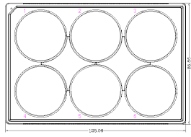

This protocol must be done under sterile conditions in the biosafety cabinet (aka the hood you split your cells in). You will set up two conditions:
- one well of cells treated with the KLP61F dsRNA (experimental)
- one well of cells that you will NOT add dsRNA to but will otherwise subject to the same steps as the experimental (untreated control)

Steps:
- Label the lid above one well “KLP61F dsRNA” and a 2nd well “Untreated”
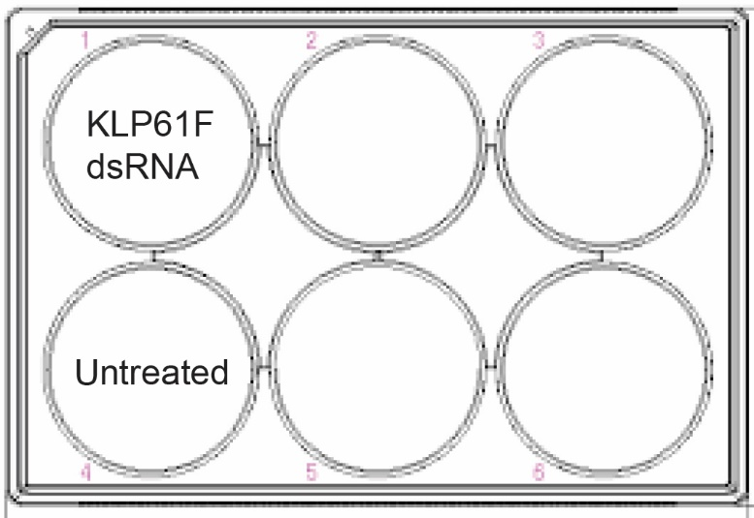
- Add 1 ml of complete Schneider’s medium (containing FBS) to each of the labeled wells

- After you split your cells, add ~250 uls of the concentrated cells to each of the wells
(we are aiming for ~50% confluency, check after ~10 minutes and - if necessary - add more cells to each well)

- Let cells adhere to the plastic for ~30 minutes

- While the cells are adhering add 5 ug of the KLP61F dsRNA to a labeled 1.5 mL Eppendorf tube

- Once the cells are adhered (after ~30 mins), add 1 mL of serum-free medium to the 5 ug of dsRNA and mix well

- Carefully remove the medium from the “KLP61F dsRNA”-labeled well - being sure to limit the removal of the semi-adhered cells (tilting the plate helps here)

- Add the serum-free medium + KLP61F dsRNA to the “KLP61F dsRNA”-labeled well

- Carefully remove the medium from the “Untreated”-labeled well

- Add 1 mL of serum-free medium to the “Untreated” well

- After 1 hour add 1 ml of serum-containing complete Schneider’s medium to each well.

- Place the plate at 24C for 2 days

Here is a video from my lab that was published in a journal called JOVE a few years back. You could watch the whole thing if you are interested or you could skip ahead to Part III (RNA Interference) at 3:29 to hear about how to set up a KLP61F RNAi.

