You have before you pots of Arabidopsis thaliana of various ages, as well as an assortment of vegetables. You should look at the real plants at least as much as you look at the pictures to follow. Feel free to pull a few plants out of the soil to see what’s underground.

Plant Functions
Because we want to figure out what our unknown genes do, we have to remember some of the things that plants do. You should be thinking of what plant structures in general, and Arabidopsis structures in particular, are associated with each of these functions:
- gas exchange (O2 and CO2, e.g.)
- acquisition of water
- acquisition of energy
- acquisition of minerals (phosphate, nitrogen, iron, e.g.)
- sex
- production of offspring
- defense against predators

Arabidopsis Structures
Beginning on page [] is a series of photographs of Arabidopsis structures.
Using these photographs, you should learn to identify the structures listed below:
- Seed
- Hypocotyl
- Roots
- Cotyledon
- First true leaf
- Petiole
- Rosette
- trichome
- Bolt
- Cauline leaf
- Flower
- Petal
- Sepal
- Carpel
- Stamen
- Pollen
- Young silique
- Mature silique

Plant Structures in Grocery Store Context
I now ask that you relate parts of Arabidopsis to some very familiar plant parts—the ones we eat. All the vegetables listed below are available in the lab for you to examine.

- Sesame seeds
- Edamame
- Green beans
- Bell peppers
- Celery
- Lettuce
- Bean sprouts
- Peanuts in shells
- Broccoli
- Beet or carrot
- Peanut in a shell

Your Assignment:
As you examine the plants,
- Match the Arabidopsis structure to the homologous vegetable, and describe its function. Fill in the tear-out table on page [ ], and submit it to your T.A.
- Make your own photograph of each Arabidopsis structure and upload your images to your Wiki. (Kate has a camera with an optical macro lens if you need something better than your cell phone.)
- Take a matching photograph of the appropriate vegetable, and upload it as well.
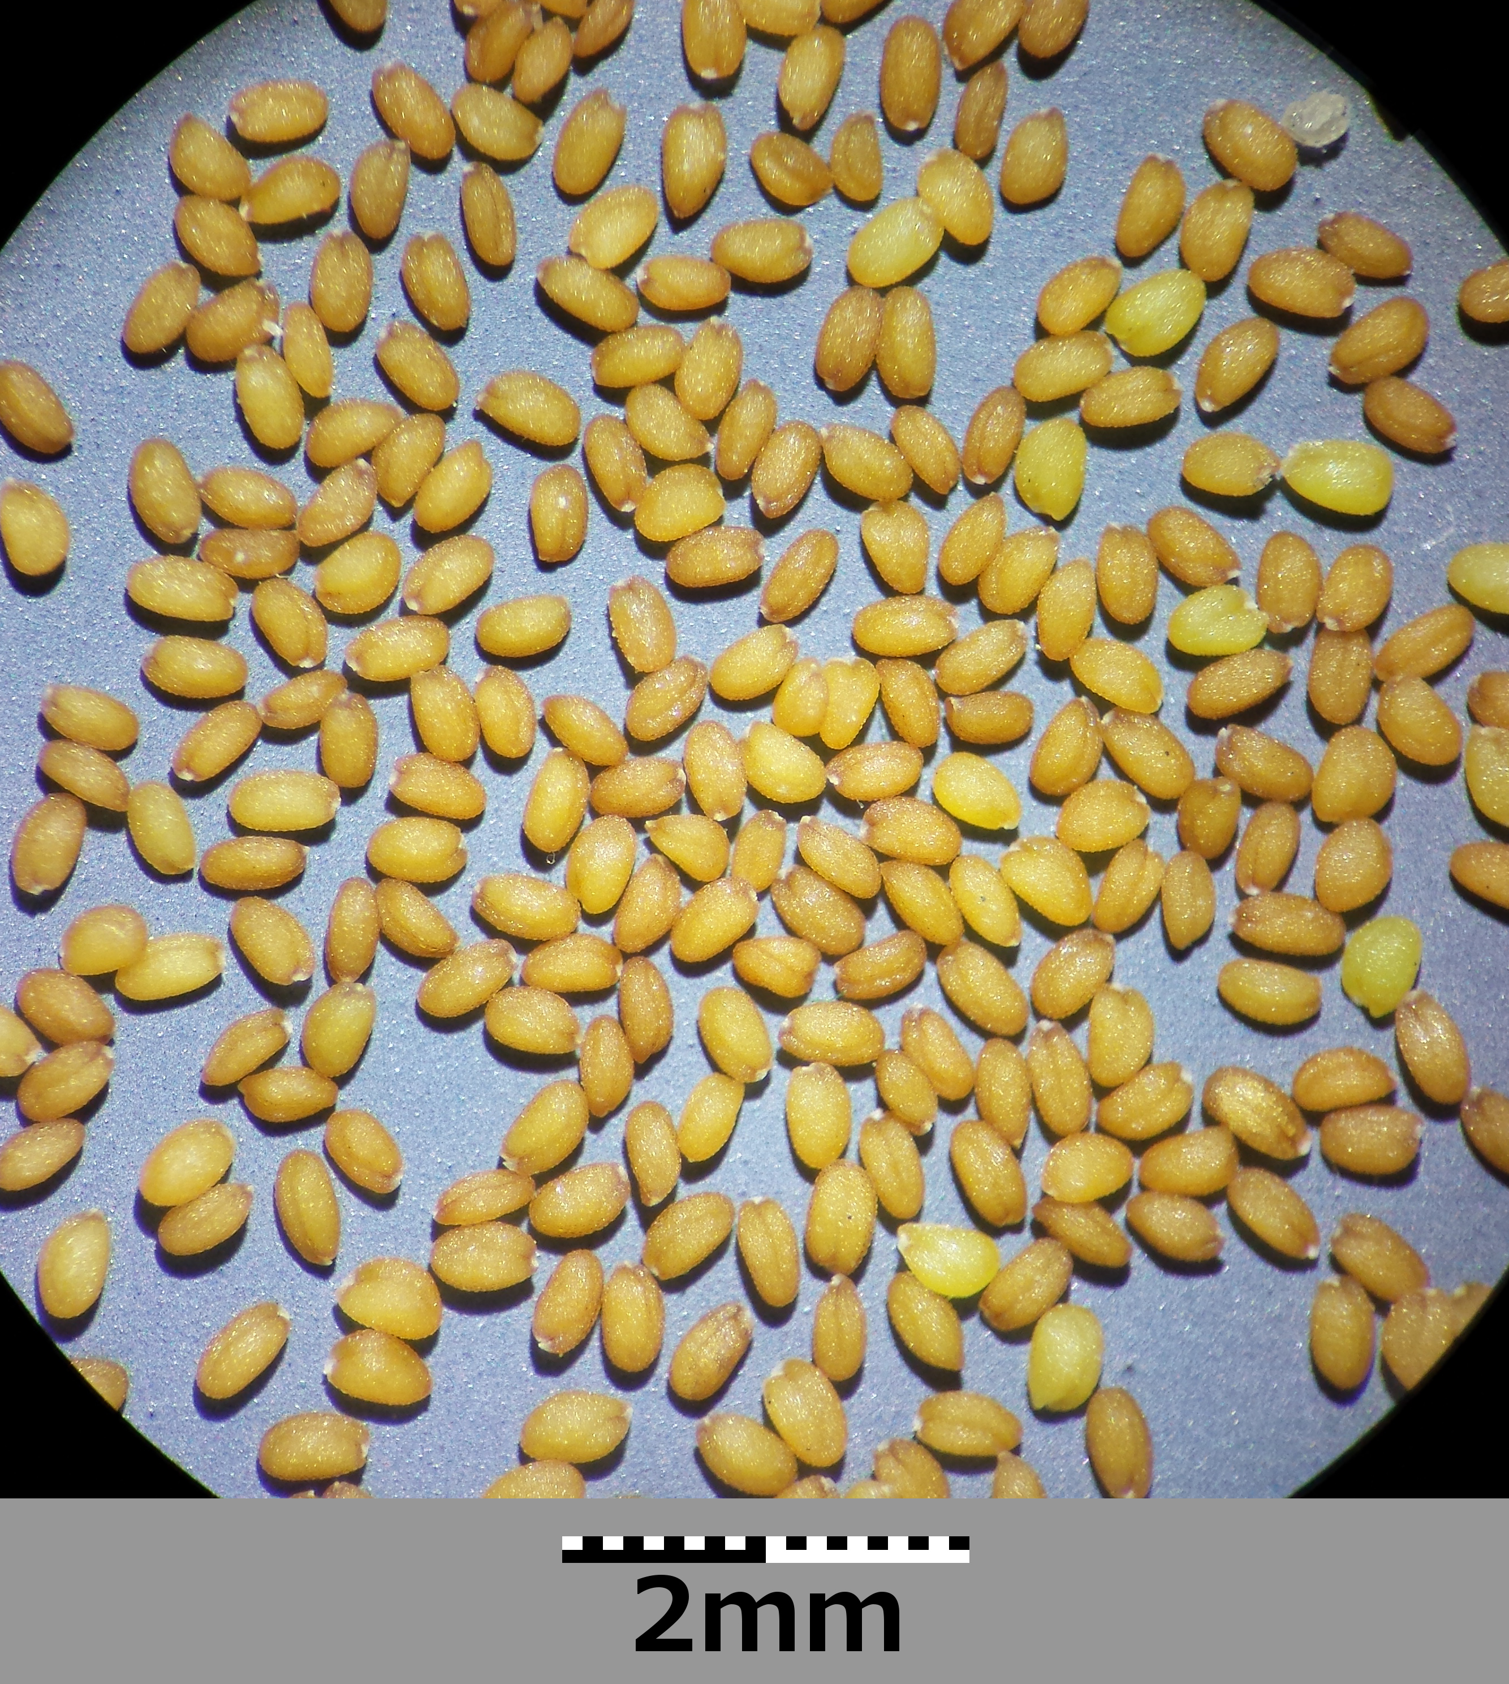
http://commons.wikimedia.org/wiki/Arabidopsis_thaliana#mediaviewer/File:Arabidopsis_thaliana_sl2.jpg
by Stefan Lefnaer, under CC-BY-SA-3.1

KATE’S GERMINATING SEEDLING PIC HERE showing hypocotyl and root hairs

KATE’S COTYLEDON PIC HERE

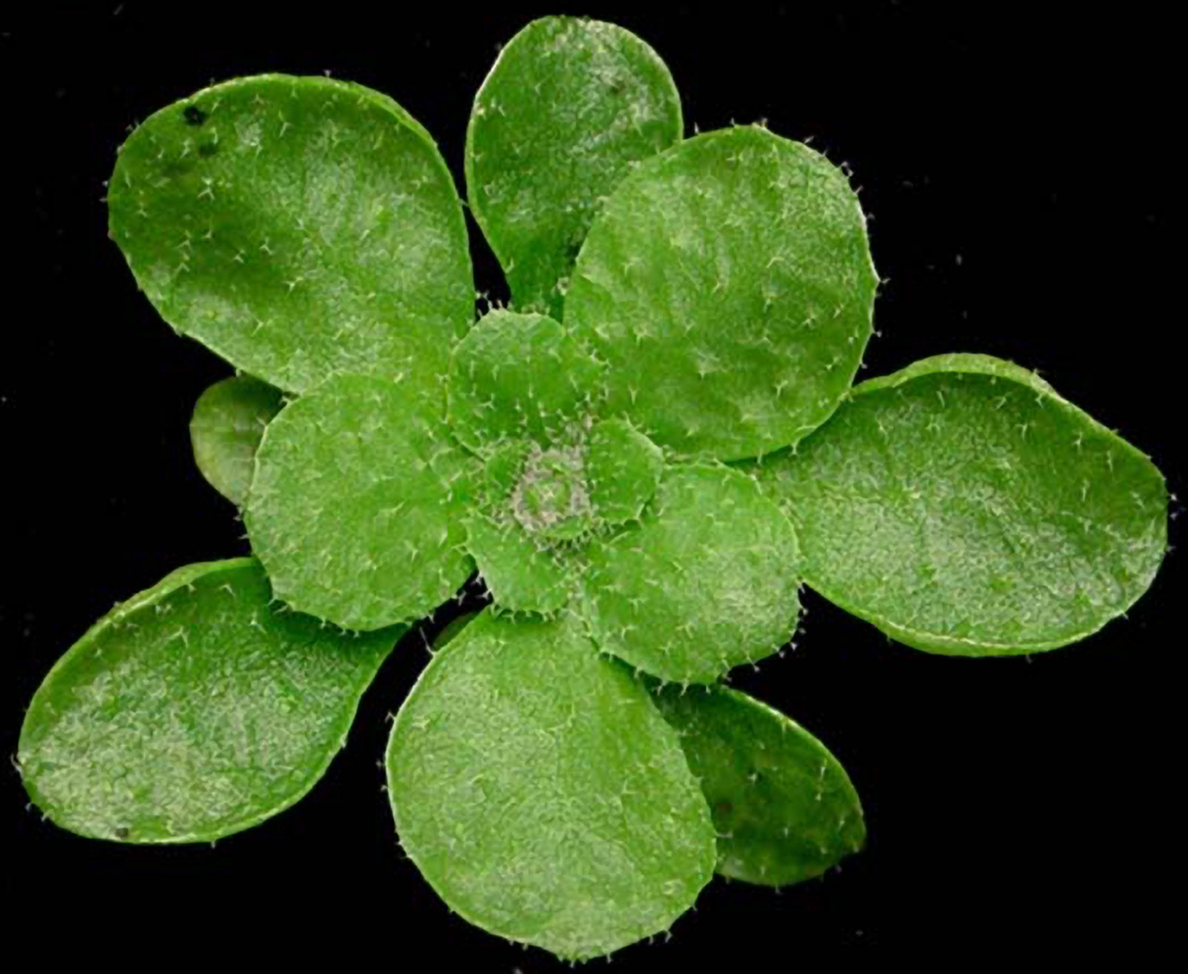
Small RNA Pathways in Plants. PLoS Biol 2/5/2004: e107. http://dx.doi.org/10.1371/journal.pbio.0020107
cc-by-2.5

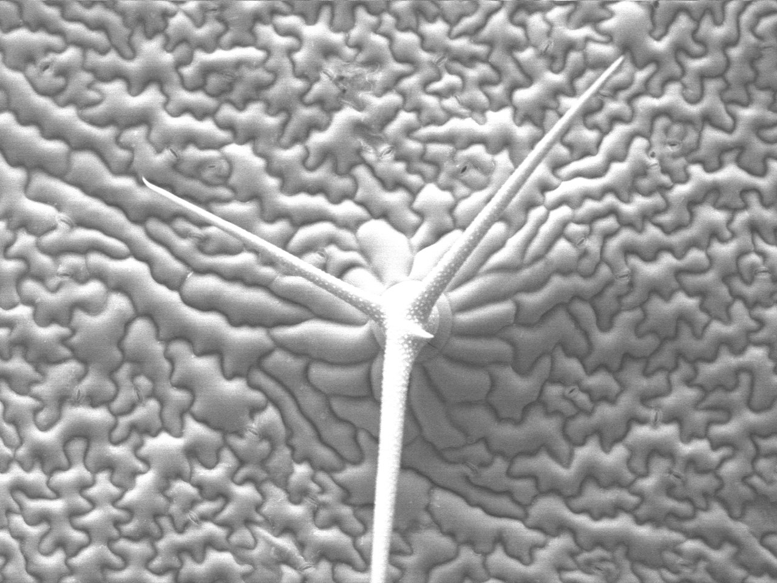
Cryo-scanning electron micrograph by Emmanuel Boutet, Creative Commons CC-BY-SA-2.5

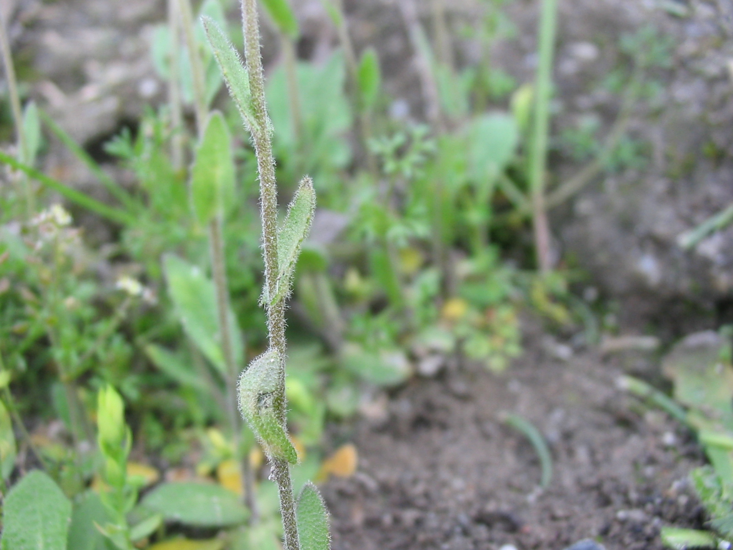
http://commons.wikimedia.org/wiki/Arabidopsis_thaliana#mediaviewer/File:Arabidopsis_thaliana_hojas_sesiles.jpg
photograph by Alberto Salguero Quiles, under CC-BY-SA-3.0, accessed 12/16/14

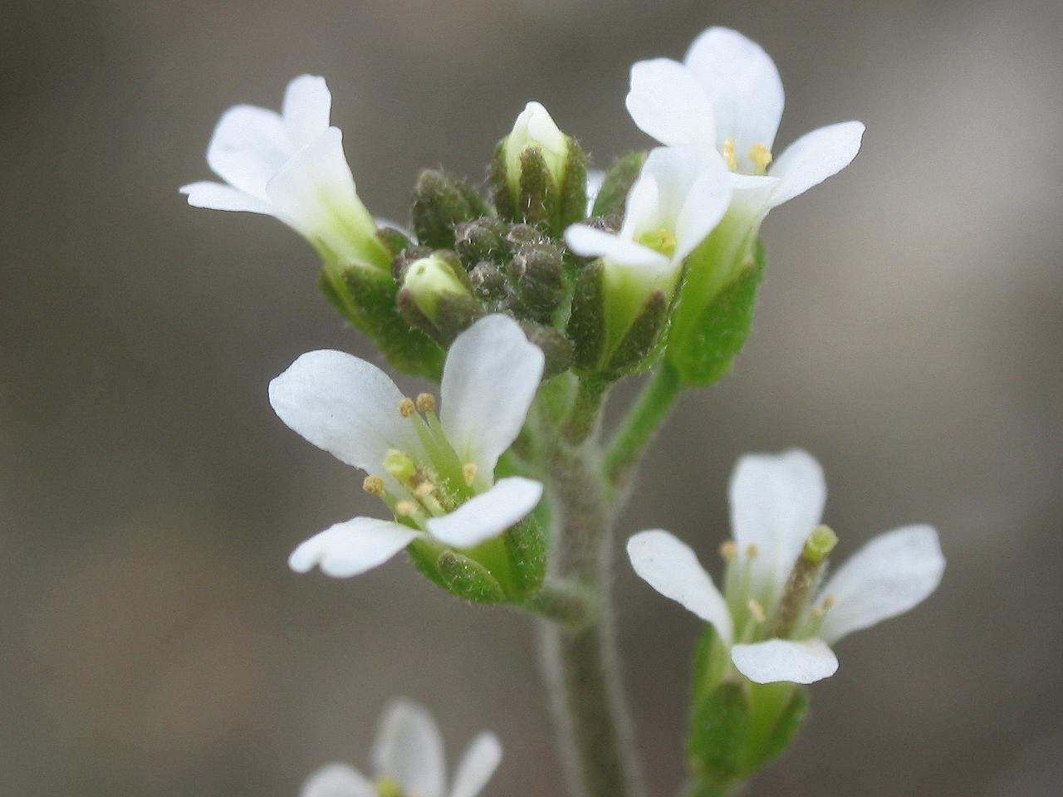
http://commons.wikimedia.org/wiki/Arabidopsis_thaliana#mediaviewer/File:Arabidopsis_thaliana_inflorescencias.jpg
photograph by Alberto Salguero Quiles, under CC-BY-SA-3.0, accessed 12/16/14

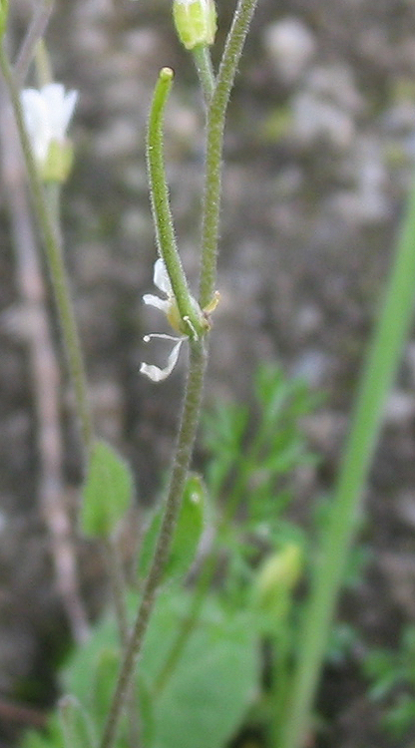
http://commons.wikimedia.org/wiki/File:Arabidopsis_thaliana_fruto.jpg
photograph by Alberto Salguero Quiles, under CC-BY-SA-3.0, accessed 12/16/14

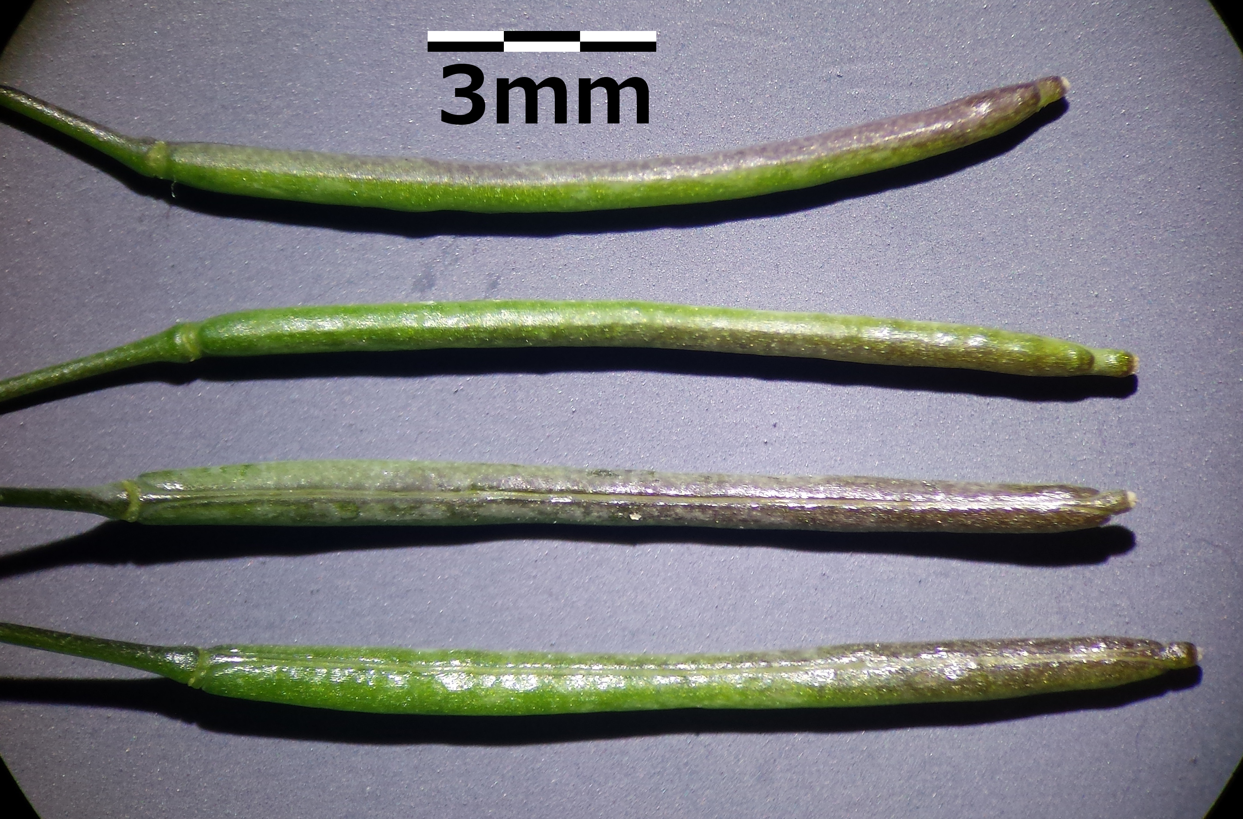
http://upload.wikimedia.org/wikipedia/commons/9/96/Arabidopsis_thaliana_sl4.jpg
by Stefan Lefnaer, under CC-SA-3.0

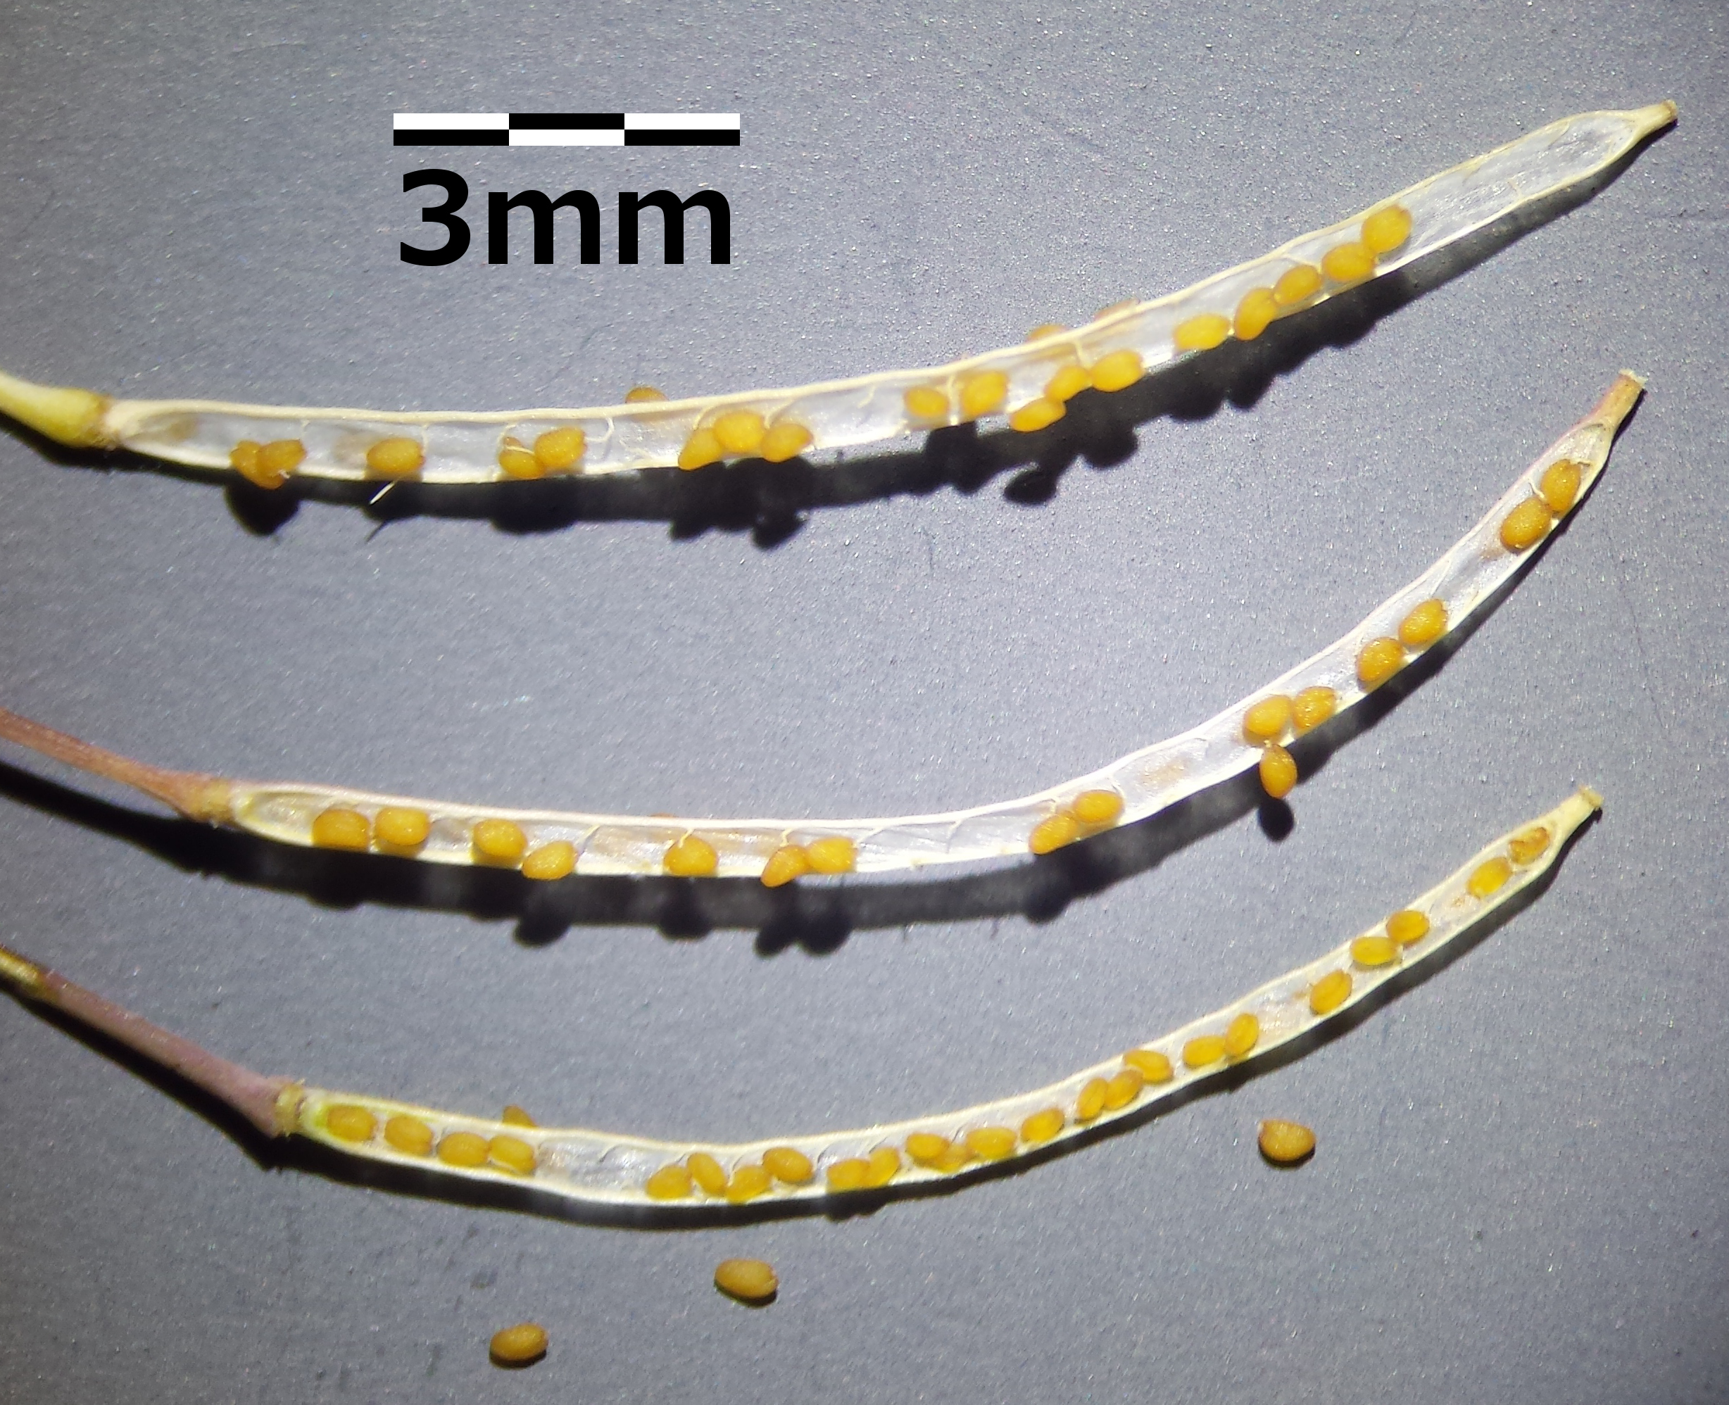
http://upload.wikimedia.org/wikipedia/commons/b/b9/Arabidopsis_thaliana_sl5.jpg
by by Stefan Lefnaer, under CC-BY-SA-3.0

NAME_____________________________

Structure | Fig # | homologous vegetable(s) | function(s)
Seed
Hypocotyl
Roots
Cotyledon
First true leaf
Petiole
Rosette
trichome
Bolt
Cauline leaf
Flower
Petal
Sepal
Carpel
Stamen
Pollen
Young silique
Mature silique

