Motic Images Plus 3.0

First confirm that both Motic Images devices and Motic Images Plus3.0 are both in the applications folder.

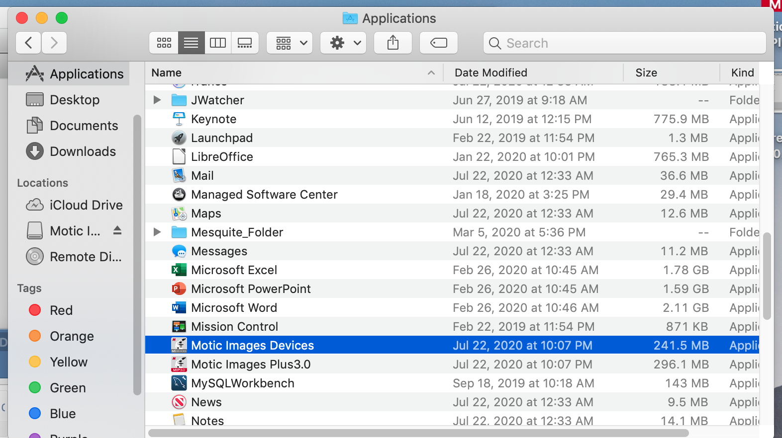

Open Motic Images Plus 3.0, and find Capture in the File menu
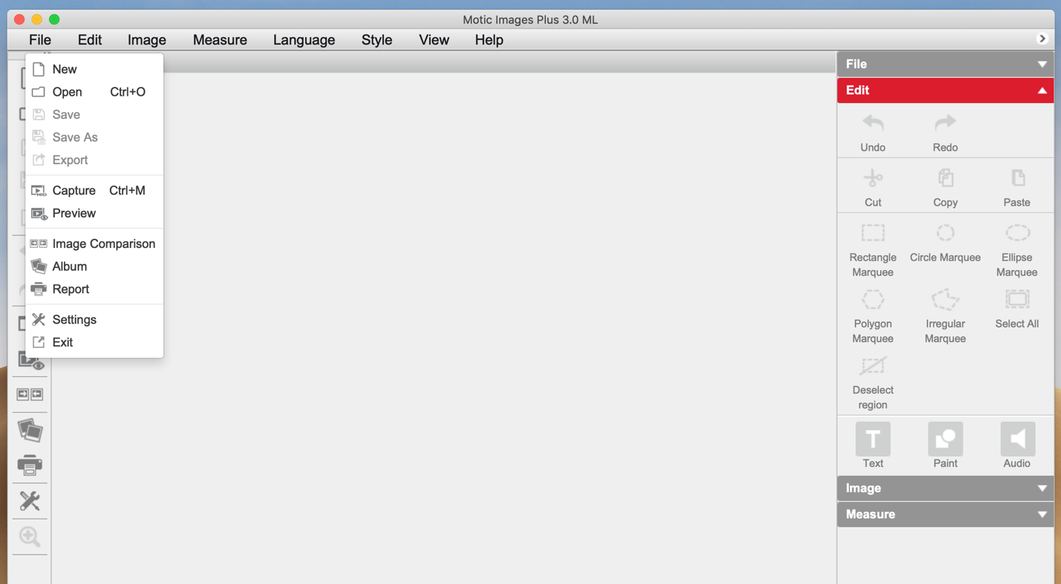
Open Motic Images Devices and chose “open” for the video device.
This shows you what the camera sees
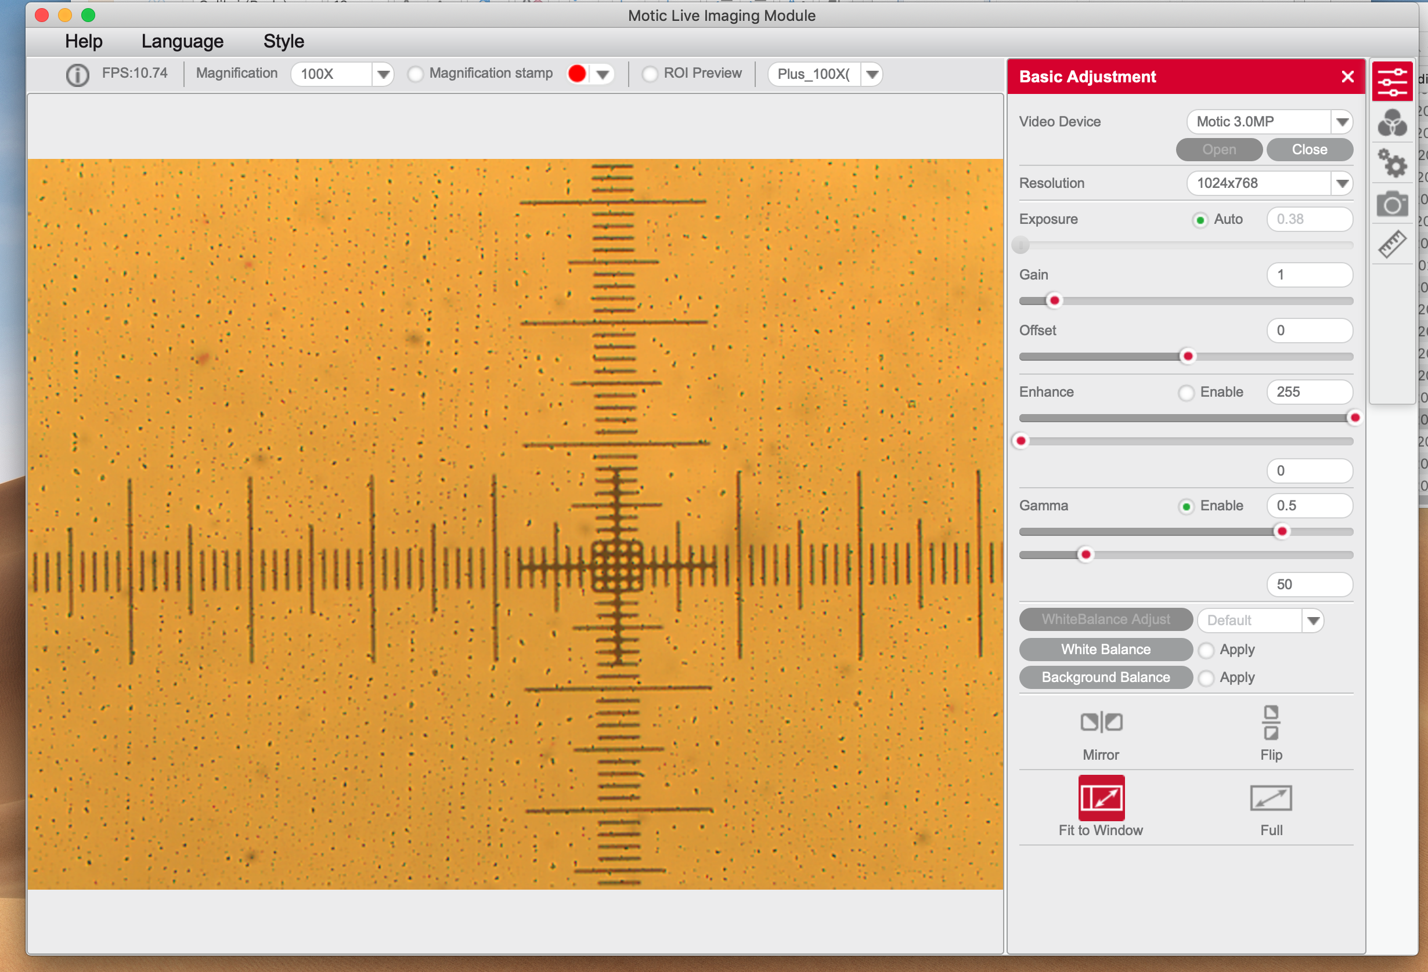

In this case, there is a micrometer on a calibration slide. Note that the software doesn’t actually know what magnification you are using; the default is 100x. You should change that with the drop-down menu. If you click the little Magnification stamp button, the magnification you have indicated will appear in the upper right corner of the image.

You can make adjustments to the light and exposure of the image using the sliders on the right.

In order to make measurements, you must calibrate the image using one of the Motic calibration slides. First, capture an image of one of the calibration circles using the camera icon. Be sure to note the magnification on the objective and the size of the circle. The images tend to go into a folder buried inside the Motic folder:
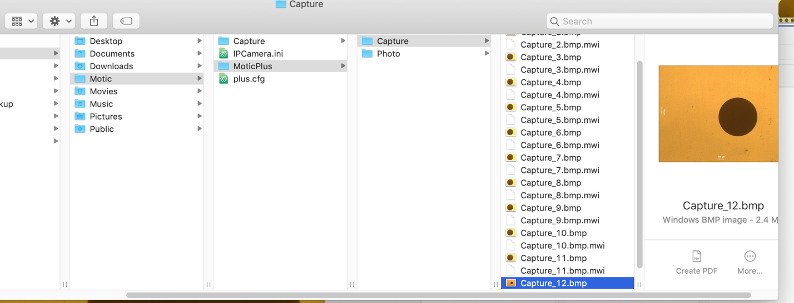

Rename the image with a name that tells you those things (e.g., 4x-600um) so you can find it when the program asks you to load it.

Open settings and choose calibration, and follow the directions.
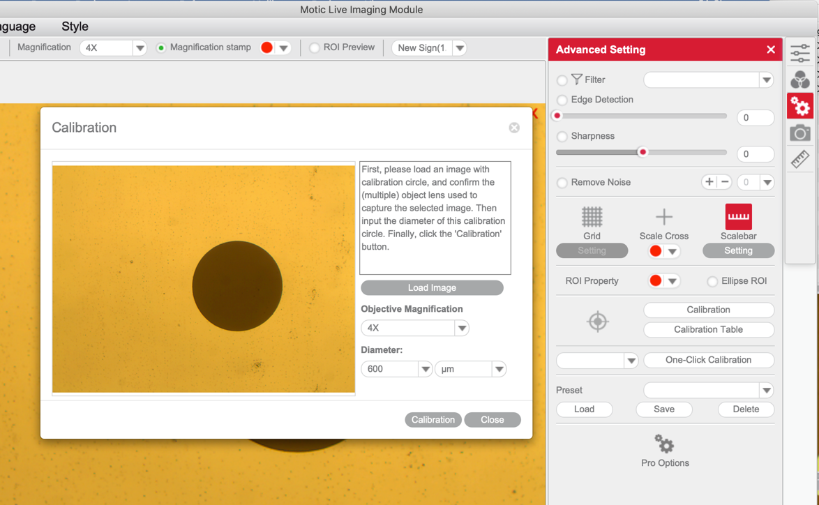

When you are finished, close the calibration window and look at your image. If you click the scalebar icon, the software will put a little scale bar on your image. Click the icon again to remove it.

To measure something, use the little ruler icon under the camera, draw a line, and the software will label it with its length. 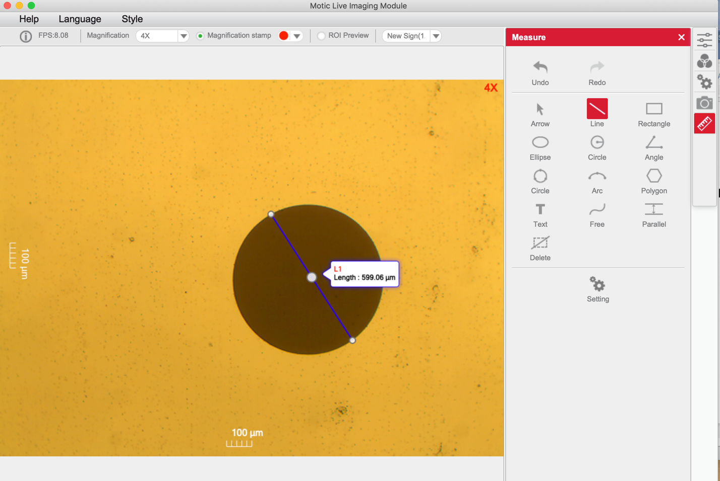

You can do a quick check of your calibration by measuring the diameter of the calibration circle, as I have done above. The circle is 600nm in diameter, which is pretty close to the length calculated by the software.

