Image Spatial Quantification
You now have several digital images of cells. What sorts of information can be gotten from these images? One obvious thing you might need to know is the size of a cell or a subcellular structure. This can be done once you calibrate the imaging system. To do this, you will use a calibrated stage micrometer, a slide that has a very fine ruler etched into it (Figure 1).
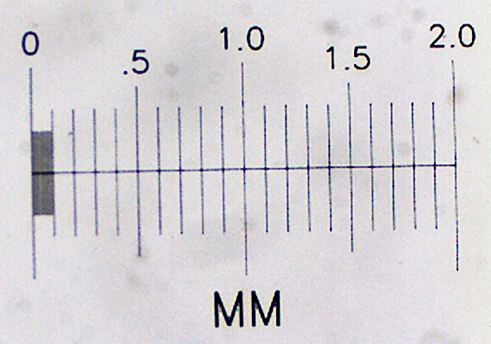
Figure 1. Stage micrometer from Ward’s Science (part # 949910)
- Examine the stage micrometer slide, and notice which side the micrometer is on. Place the slide on the stage with that side facing the objective lens. Look at the image with the 10× objective.
- Looking at it from above the microscope stage, move the micrometer so it is near the center of the objective lens. Now find it through the microscope, then center and focus it.
- Get the camera image of the stage micrometer, optimize it and be sure it is in good focus.
- Take a single image of the stage micrometer and save it.
- Switch to the ImageJ window. Click on the line symbol and draw a straight line from one stage micrometer hash mark to another. It will be most accurate if you draw the line from hash marks as far apart as possible. (Why?)
- From the “Analyze” pull down menu select “Set scale…”. The window that pops up will show you the distance in pixels of your line. You need to type in the actual distance between the two hash marks that you used. If you can’t figure this out, ask for help. Be sure to use the correct units of measurement in the “Set Scale” box. (1 cm = 10⁴ μm.) Leave the aspect ratio set at 1. Your camera has square pixels, so the aspect ratio (height:width) is 1.
- Use “Analyze > Tools > Scale Bar”. Save this in a separate file, appropriately named, using the “Save as” button. Make another Word or Open Office file with this image and an appropriate caption. When a scale bar appears in an image you should always give the dimensions of the scale bar, in the caption instead of adding that number to the image. The scale bar is usually positioned in one corner of the image where it will not obscure any important image detail.
- Determine the size that a camera pixel represents when the 10× lens is used. You can do this by dividing the known distance between hash marks in part 6 by the distance in pixel units from part 6. This value is the number of μm per pixel (or cm per pixel if you prefer). This tells you how much of the specimen area falls on each pixel in the camera. This value will remain the same for any future use of this objective lens and camera in this microscope. The value will be different for different lenses (and for different cameras, if you happened to use a different one).

Adapted from Wadsworth, et al., 2015, Bioimaging Lab Manual, Academx Publishing.

