Welcome to UMass Summer College Research Intensives.

Lab Boot Camp Manual
(always a work in progress)

Goals for this short (2-morning) Lab Boot Camp
- Become familiar with lab culture
- Brush up on some basic lab techniques
  - Practice Pipetting, Serial Dilutions
  - Extract DNA
  - Run a gel
  - Do some Pubmed searches and bioinformatics
- Get to know each other and where other Summer College students are working.

Overview
Day 1 (Tuesday, 9:00-12:00):
Introductions, Boot Camp overview, discuss lab notebooks and lab culture
Pipette exercise/competition (color and weighing)
DNA isolation: Which cells have the most DNA? (be quantitative from the start)
Day 2 (Thursday, 9:00-12:00):
DNA quantification and quality assessment: Nanodrop method

Serial dilutions! How accurate can you be? Linear data?
DNA Quality: Run gel, take cellphone pix & send to Rolf

Literature search (as time permits): Pubmed search

Instructors:
Rolf Karlstrom, Biology, Karlstrom@bio.umass.edu
Kate Dorfman, Biology, kdorfman@bio.umass.edu
TAs:
Moss Glater (Karlstrom Lab), mglater@umass.edu
Leah Keeffe (Mt. Holyoke College, Markstein lab)
Mahin Hasan (Mt. Holyoke College, Markstein lab)

Table of Contents

Notes On Laboratory Safety 3
Lab Day 1 4
Exercise #1: Introduction to micro-pipetting 4
Testing Accuracy and Reproducibility in 2 ways 4
Exercise #2: DNA Extraction 8
Lab Day 2: 9
Procedure for Nanodrop DNA Quantification 10
Agarose Gel Electrophoresis 12
Literature Search Using PubMed 14
Appendices 16
Example Lab Notebook Entry 16
Nanodrop Blanking and Absorbance Calculations 17
DNA Molecular Weight Standard 18
Metric Prefixes 19



A useful resource:

Notes On Laboratory Safety

Personal protection
We do very little in this course that could result in a fire or an explosion. We will, however, be using a few reagents (in very small amounts and low concentrations – be reassured) that have the potential to cause harm. We will alert you to whatever dangers we see in the lab. Your best bet for protecting yourself is not to get anything in your mouth, eyes, or breaks in your skin. Do not eat or drink or apply lip balm or fix your contacts in the lab. Wash your hands: after you handle reagents, before you touch your face, before you leave the room, before you have a snack. Wear gloves: while you handle anything that might hurt you, or that you might contaminate. Take your gloves off: whenever you move from wet bench activities to computer keyboard, or whenever you have touched something you don’t want to spread around the room. Wear your safety goggles: whenever you handle liquids that could splash or anything that might shatter.
Move slowly to reduce spills and breakage.

Cleaning up
We will alert you to the proper disposal techniques for the reagents and materials we use in this lab. Some are quite benign and can go right in the trash or down the drain, and others require special handling. Check the Clean up section for each lab for specific instructions.

Discarding Waste
There are many different types of waste in this lab, each disposed of separately:
- recyclable paper or containers
- broken glass (unrecyclable, dangerous to handle)
- sharps (small sharp objects like razor blades)
- biohazard waste (biological specimens that might be infective or invasive)
- hazardous waste (toxic, corrosive, or flammable waste)
- regular trash (solid waste that is not any of the above)
- benign liquid waste (liquid waste that is not hazardous or infective)

Always ask whenever you have any doubt about anything, including equipment use, techniques, and disposing of something.

Lab Day 1

Exercise #1: Introduction to micro-pipetting

Testing Accuracy and Reproducibility in 2 ways

Goal for this exercise:
Master micropipetting technique.

Introduction
One of the most important skills you will need in this course is your ability to use a micropipettor. Micropipettors are used to make accurate measurements of extremely small volumes—from one milliliter down to one microliter (1 mL to 1 μL). Most of what we do in molecular biology involves manipulating volumes of liquid in this range. If you learn to do it accurately now, your experiments will go much more smoothly later.

Micropipettor Basics
These are precision scientific instruments, and must be treated with respect. The pipettor is used to draw liquid up into a cheap disposable tip. The three pipettors you will use take up and deliver liquids in the volume range from ~0.5 μL to 1.0 mL. Your instructor will show you how to use this device. Read and follow these guidelines to maintain the accuracy and precision of your pipettors.
Rotate the volume adjustor to the desired setting. Note the change in plunger length as the volume changes. Be sure to properly locate the decimal point when reading the volume setting. (Your instructors will demonstrate.)
You have three sizes of pipets in this lab: LTS20s, which can measure between 1 μL and 20 μL; LTS200s, which can measure between 21 μL and 200 μL; and LTS1000s, which can measure between 200 μL and 1000 μL (1 mL).
There are three numbers on the display of each pipettor. Look at the top of the pipet to see which one you are holding, then look at the display. The numbers represent volumes as shown below. The color change represents crossing the decimal place or changing units.
L 20 |  |  | L 200 |  |  | L 1000
1 | 10 | µL | 1 | 100 | µL | 1 | 1000 | µL = 1.0 mL
0 | 1 | µL | 0 | 10 | µL | 0 | 100 | µL
0 | 0.1 | µL = 100 nL | 0 | 1 | µL | 0 | 1 | µL
Firmly seat a proper-sized tip on the end of the micropipettor. The tips boxes are color-coded to match the label on the plunger.
When withdrawing or expelling fluid, always hold the tube firmly between your thumb and forefinger, keeping it nearly at eye level to observe the change in the fluid level in the pipet tip. Do not pipet with the tube in the test tube rack or have another person hold the tube while you are pipetting.
Hold the tube in your hand during each manipulation. Open the top of the tube by flipping up the tab with your thumb. During manipulations, grasp the tube body (rather than the lid), to provide greater control and to avoid contamination of the mouth of the tube.
For best control, grasp the micropipettor in your palm and wrap your fingers around the barrel; work the plunger (piston) with the thumb. Hold the micropipettor almost vertical when filling it.
Notice the friction “stops” on the two-position plunger with your thumb. Depressing to the first stop measures the desired volume. Depressing to the second stop introduces an additional volume of air to blow out any solution remaining in the tip.

To withdraw the sample from a reagent tube:
- Depress the plunger to first stop and hold it in this position. Dip the tip into the solution to be pipetted, and draw fluid into the tip by gradually releasing the plunger. Be sure that the tip remains in the solution while you are releasing the plunger.
- Slide the pipet tip out along the inside of the reagent tube to dislodge any excess droplets adhering to the outside of the tip. To avoid future pipetting errors, learn to recognize the approximate levels to which particular volumes fill the pipet tip.
- If you notice air space at the end of the tip or air bubbles within the sample in the tip, carefully expel the sample back into its supply tube. Collect the sample at the bottom of the tube by pulsing it in a microcentrifuge.

To expel the sample into a reaction tube:
- Touch the tip of the pipet to the inside wall near the bottom of the reaction tube into which the sample will be emptied. This creates a capillary effect that helps draw fluid out of the tip.
- Slowly depress the plunger to the first stop to expel the sample. Depress to second stop to blow out the last bit of fluid. Hold the plunger in the depressed position.
- Slide the pipet out of the reagent tube with the measurement plunger depressed, to avoid sucking any liquid back into the tip.
Use the ejector button (located at the back and different from the plunger) to remove the tip into a waste container.

Important pipettor don’ts:
- Never rotate the volume adjustor beyond the upper or lower range of the pipet.
- Never use the micropipettor without the tip in place; this could ruin the piston. Pipettors use disposable plastic tips. Every molecular biology lab circulates its own version of the story of the not-too-bright grad student who did not use a tip. Do not be this student!
- Never invert or lay the micropipettor down with a filled tip; fluid will run back into the piston.
- Never let the plunger snap back after withdrawing or expelling fluid; smooth motions are the key to success.
- Never immerse the barrel of the micropipettor in fluid. Only the disposable tip touches the liquid.
- Never reuse a tip. Tips are pretty cheap (about $0.59 per rack). The risk of cross contaminating your solutions is too great to get tricky with tips. Just use a new one every time unless there is no possibility of cross contamination—like if you are pipetting the same solution into multiple empty tubes.

Day 1, Exercise #1: Pipetting
Overview: An essential property of good science is that an experiment gives the same results even in different hands. Repeated measurements of the same thing should give the same value, no matter who makes the measurement. Precision and accuracy are different; ideally we will get you to achieve both in this exercise.
You will use 2 methods to examine pipettor accuracy and repeatability (precision?). Since we know how much a given volume of water weighs (1 ml = 1 gram), it is relatively simple to test pipettors by weighing different amounts of water. For this exercise you will weigh 2 volumes of water for each pipettor (e.g. 2µl and 10µl for the p20) and do each measurement 10 times to see how reproducible you can become. You will also use a colorimetric method to check for accuracy.

Pipette calibration
First figure out what each of these volumes of water should weigh, and which pipet should be used to dispense that volume:
µL |  | mL | weight (g) |  | weight (mg) | pipet
1000 | = |  |  | =
100 | = |  |  | =
10 | = |  |  | =

Weighing Method Procedure:
- Put a weigh boat or piece of weigh paper on the balance pan, and zero the balance.
- Dispense the lesser volume of water for each pipettor (e.g. 2µl for the p20) onto the boat/paper. Record the result.
- Re-zero the balance, and dispense the same volume onto the same paper. Record your result.
- Repeat for a total of 10 measurements (no need to change the weigh paper in between)
- Repeat for the higher volume for the same pipettor
- Repeat for the other two pipettors.
- Check discrepancies with your instructor.

Record all results in a table in your lab notebook and make a hand-drawn graph showing the weights you got with each trial. Advanced: Enter the same data into an excel spreadsheet. Make a line graph, a bar graph, and dot plot of your data. Use excel to calculate and plot standard deviation.
LAB TIP: You should do a scaled down version of this when you get to your new lab!!! It is better to pay to have your pipette calibrated now than to get inaccurate experimental results all summer long.

Color Method Procedure:
- Cut a sheet of parafilm long enough to cover the table provided.
- In each space, pipette 5µL of bromothymol staining solution onto the parafilm. Think about whether you need to change tips between droplets.
- Check to make sure that all drops are the same size. You can easily remove a drop and re-do it if necessary.
- Using a new tip each time, add the requisite volume (in µL) of sodium phosphate dibasic to each droplet of stain. (Why do you suppose you must change tips?)
- Add the requisite volume of sodium phosphate monobasic to each stain-dibasic droplet.
- If you do not have a color gradient from yellow, through green, to blue, you have made an error somewhere.
- Check that each mixed drop is the same size as the others.
- Take a picture of your results and send it to the instructor.

Discussion/thought questions:
- What is the difference between precision and accuracy?
- Are your pipettors accurate?
- Are your pipettors precise?
- Did your technique improve with time?
- What could be sources of variability?
- Could/Would/Should you save plastic tips/the environment by re-using tips? (try it!)

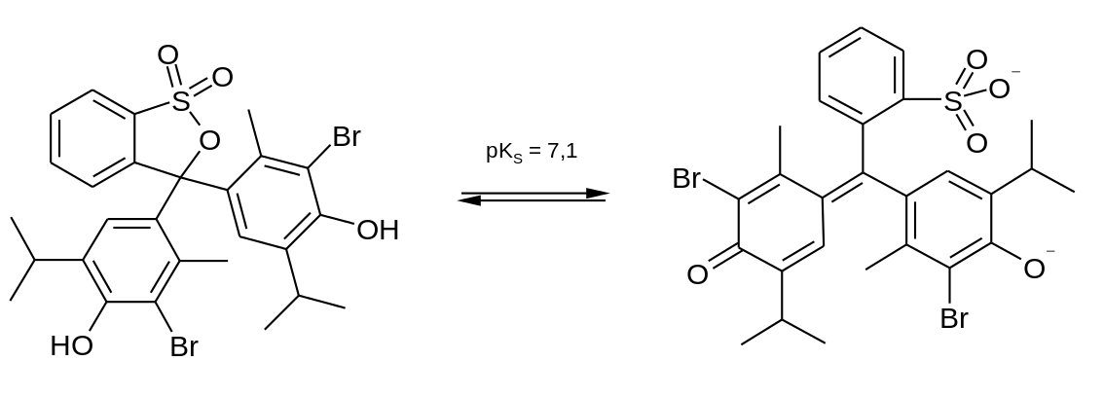
The chemistry behind the color method: why/how does the color system work?
Bromothymol blue is a pH indicator. It has a multiple conjugated ring structures (6-carbon rings with alternating single and double bonds) that give it a plane of electrons that interact readily with light. Slight changes in acidity alter the configuration of these rings and change the particular wavelengths it absorbs.
By Steffen 962 - Own work, Public Domain,
https://commons.wikimedia.org/w/index.php?curid=15179368

Sodium phosphate buffer works like this:
Sodium phosphate monobasic  (one univalent metal) |  |  |  | Dihydrogen phosphate ion  Hydrogen donor  acidic
NaH₂PO₄ | ↔ | Na⁺ | + | H₂PO₄–

Sodium phosphate dibasic  (two univalent metal) |  |  |  | Hydrogen phosphate ion  Hydrogen acceptor  basic
Na₂HPO₄ | ↔ | 2Na⁺ | + | HPO₄^{2–}

Dihydrogen phosphate ion  Hydrogen donor  acidic |  |  |  | Hydrogen phosphate ion  Hydrogen acceptor  basic
H₂PO₄– | ↔ | H⁺ | + | HPO₄^{2–}
If you add H⁺, the equilibrium shifts toward dihydrogen phosphate
If you add OH–, the equilibrium shifts toward hydrogen phosphate
But the concentration of H⁺ stays the same. (∴ a buffer!)
 |  |  |  |  | H₃PO₄
 |  |  |  |  | ↑↓ | pKa′ | 2.12
monobasic | NaH₂PO₄ | ↔ | Na⁺ | + | H₂PO₄–
 |  |  |  |  | ↑↓ | pKa′′ | 7.21
dibasic | Na₂HPO₄ | ↔ | 2Na⁺ | + | HPO₄^{2–}
 |  |  |  |  | ↑↓ | pKa′′′ | 12.32
tribasic | Na₃PO₄ | ↔ | 3Na⁺ |  | PO₄^{3–}

Exercise #2: DNA Extraction

Goal:
Extract DNA from various leafy plants. We’ll try to see if different plants have different DNA content (wt DNA/wt tissue), so make sure you weigh your starting sample well.

Introduction
In this lab, we will extract DNA from a variety of dried plant leaves. We are trying a ridiculously quick and easy protocol for the first time from the paper “A simple and efficient genomic DNA extraction protocol for large-scale genetic analyses of plant biological systems” (Sika et al, 2015). Tomorrow we will see if it works and examine the DNA to make some conclusions about DNA quality, nucleic acid content in cells, and see if we can learn anything about the relative sizes of plant genomes.

Procedure
- Weigh about 0.5 g of 2 different dried leaf/spice samples. Note the exact weight and type of leaf/spice in your lab notebook. You will be comparing the amount of DNA you get from the two samples.

- Grind the tissue with a mortar and pestle to make fine powder.

- Place 25 mg of the ground sample in an eppendorf (1 eppendorf per sample)

- Add 1000 µl (1 ml) of extraction buffer (1% SDS, 0.5 M NaCl) to each tube

- Microcentrifuge tubes at Max speed for 5 min

- Transfer 500 µl of the supernatant (liquid above pellet) from each tube into new tubes

- Add 500 µl isopropanol and mix by gently inverting the tubes.

- Place on ice for 5 minutes

- Microcentrifuge tube at Max speed for 5 min

- Use a micropipettor to carefully remove the supernatant, wash pellet w/ 500 µl of 70% ethanol *You want the pellets!*

- Microcentrifuge tubes at 13,500 rpm for 2 minutes

- Use a micropipettor to remove as much ethanol as possible, gently blot away excess ethanol w/ paper towel, let pellets air dry

- Dissolve DNA in 50 µl T₁₀E₁

- Label your tubes carefully with your group initials, type of DNA (plant) and the date. Put it in a rack in a freezer box. We’ll use these samples on Day 2.
- Write in your lab notebook what you did, either “exactly as in manual”, or “as in manual, except that …” Give the date, and what label you put on the tube.
- Clean-up as directed on board.

Lab Day 2:
DNA Quantification, Agarose Gels, Bioinformatics

Goals for this lab:
- Quantify DNA with the Nanodrop and maybe plate reader
- Quantify and Examine Nucleic Acids on a gel.
- Practice some basic bioinformatics

Introduction:
Reliable measurement of DNA concentration is important for many applications in molecular biology. DNA quantification is generally performed by spectrophotometric measurement of the absorption at 260 nm, or by agarose gel analysis. In this exercise you will try both.

DNA quantification by molecular absorbance spectroscopy.
DNA concentration can be determined by measuring the absorbance at 260 nm (A₂₆₀) in a spectrophotometer using a UV-transparent cuvette (usually quartz). In molecular absorbance spectroscopy, a beam of ultraviolet or visible light (P_{o}) is directed through a sample. Some of the light may be transmitted through the sample (P). Light that was not transmitted through the sample was absorbed. Transmittance (T) is defined as the ratio of P/P_{o}. Absorbance (A) is defined as -log(T). The light that was absorbed is what we care about: the absorbance at 260 nm, or A₂₆₀.
Unfortunately, spectrophotometric measurement does not differentiate between the two nucleic acids commonly found in a cell (DNA and RNA). The OD260 measurement thus tells you something about the total amount of nucleic acid in a preparation, but can’t let you measure the concentration of DNA in a preparation that also contains RNA. RNA contamination of a DNA preparation can lead to overestimation of DNA concentration, if spectroscopy is the only method used to determine concentration. You will thus also run your samples on agarose gels with and without RNAse to see what the nucleic acids “look” like.

Procedure for Nanodrop DNA Quantification

Module Startup
When the software starts, you should see this message:
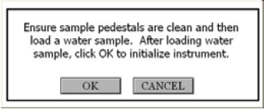

For best results, ensure measurement pedestal surfaces are clean, load a water sample onto the lower measurement pedestal and then click ‘OK’. The message “Initializing Spectrometer- please wait” will appear. When this message disappears, the instrument will be ready for use. All data taken will automatically be logged in the appropriate archive file.

Measure (F1)
Each time a software module is opened (initiated), the Measure button is inactive as noted by its “grayed-out” appearance. A blank must first be measured before the Measure button will become active.
The Measure button is used to initiate the measurement sequence for all samples (non-blanks). It is actuated by depressing the F1 key or clicking the Measure button. The entire measurement cycle takes approximately 10 seconds.

Blank (F3)
Before making a sample measurement, a blank must be measured and stored (see “Nanodrop Blanking and Absorbance Calculations” on page 17 for more details on absorbance calculations). After making an initial blank measurement, a straight line will appear on the screen; subsequent blanks will clear any sample spectrum and display a straight line, as shown in the following image:
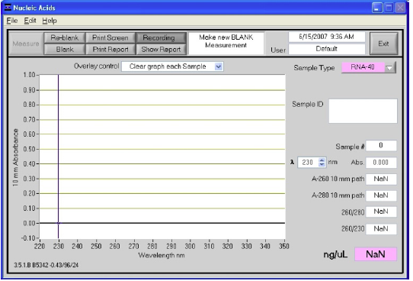
For the most consistent results, it is best to begin any measurement session with a blanking cycle. This will assure the user that the instrument is working properly and that the pedestal is clean.

Illustrated Procedure:
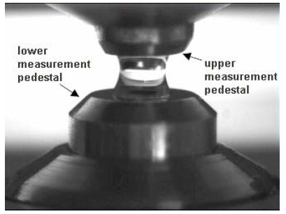
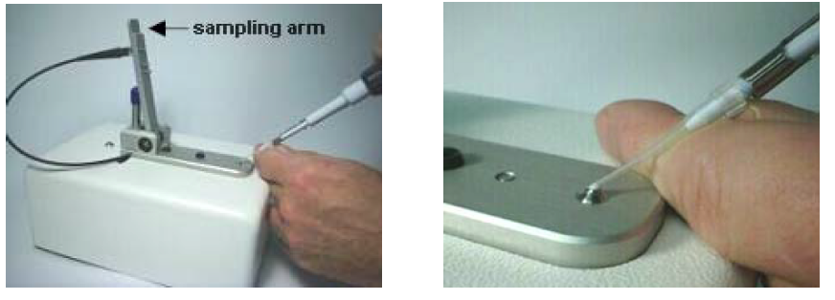
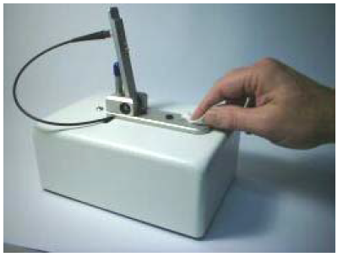
            - With the sampling arm open, load a 1µL blank sample (the buffer, solvent, or carrier liquid used with your samples) onto the lower measurement pedestal. Make sure there are no bubbles!

            - Close the sampling arm. The sample column is automatically drawn between the upper and lower measurement pedestals. Click the “Blank” button (F3)
            - When the measurement is complete, open the sampling arm and wipe the sample from both the upper and lower pedestals using a soft laboratory wipe. Simple wiping prevents sample carryover in successive measurements for samples varying by more than 1000-fold in concentration.
            - Analyze an aliquot of the blanking solution as though it were a sample. This is done using the “Measure” button (F1). The result should be a spectrum with a relatively flat baseline. Wipe the blank from both measurement and pedestal surfaces and repeat the process until the spectrum is flat.
            - Add 1µl of your most dilute sample. Record the measurement.
            - Wipe and repeat with next higher concentration of DNA sample
            - Repeat.
Record the A280 and A260 measurements and calculate the ratio to get a feel for the purity of your sample. For pure DNA the ratio will be 1.8

Agarose Gel Electrophoresis
Quantification of DNA can also be done using agarose gel analysis. This method is only effective with small amounts of DNA, since high concentrations of DNA cannot be accurately measured this way. As little as 5 ng DNA can be detected by agarose gel electrophoresis with ethidium bromide staining. In this method, the DNA sample is run on an agarose gel alongside known amounts of DNA standards. The amount of sample DNA loaded can be estimated by comparison of the band intensity with the standards using a scanner or imaging system.
Quantification using agarose gel electrophoresis is also extremely useful when DNA samples are contaminated with RNA, since RNA is separated from DNA in agarose gels by virtue of the difference in length (size) of an average genomic DNA fragment versus the average size of a mRNA, tRNA or rRNA molecule. RNA is small: tRNA is only ~100 nucleotides (nt) long, and mRNA averages ~1.5 kilobases (kb), depending on the size of the encoded protein. Genomic DNA is theoretically the size of a whole chromosome (1000s of kb), although breakage during handling causes the size of an extracted DNA sample to be smaller (~34-50 kb). By analyzing DNA that has been physically separated from RNA on agarose gels, the concentration of DNA can be measured in the absence of contaminating RNA.

Procedure:
Kate has nicely provided pre-measured and melted agarose for each group.
- Assemble your gel boxes with the help of your instructors (don’t forget the combs!),
- Pour in the melted agarose
- Let the agarose harden for 20’ or so
- While your agarose hardens, make serial dilutions of your DNA (see illustration on board):
  - Take 2 µl of your DNA sample and add to 18 µl T₁₀E₁ = 1:10
  - Take 2 µl of this 1:10 dilution and add to 18 µl T₁₀E₁ = 1:100
- Remove the combs, add running buffer
- Put 3x 2 µl drops of DNA Loading buffer onto a piece of parafilm, label 1, 1:10, 1:100
- Add 10µl of your original DNA sol’n and each serial dilution (1:10 and 1:100) to the 2µl loading buffer drops. Mix by pipetting up and down
- Add samples in order to the gel (7 lanes total, each group members should load a few lanes)
DNA Markers
DNA #1: 1, 1:10, 1:100
DNA #2: 1, 1:10, 1:100
- Run the gels as instructed.
- Photograph the gels with your cell phones
- Send the photo to Rolf (we’ll compare results at the end of the lab.)

Clean-up as directed

Record the following in your notebook:
- Report both the yield (total amount in μg) and the concentration (in μg/μL) of DNA that you purified. What sample gave the highest yield.
- Assess the quality of your genomic DNA preparation.
- If you had problems with your DNA purification, where do you reckon the problems arose? Be specific – “experimental error” explains nothing.
- What could explain the different yields from different samples?
Figure Showing Serial Dilutions
Step 2: Add 2 µl of 1:10 dilution to 18 µl solvent = 1:100
Step 1: Add 2 µl sample to 18 µl solvent = 1:10
Step 3: Add 2 µl of 1:100 dilution to 18 µl solvent = 1:1000

Literature Search Using PubMed

PubMed provides free access to a database of journal articles in the national library of medicine (MEDLINE) and additional life science journals. This resource is very useful for retrieving abstracts and articles for research.

[The Web of Science is another database, and includes some articles not found in PubMed. Access to the web of science is via the Umass library, and you need to sign in to gain access.]

An online tutorial for PubMed can be found here: https://www.nlm.nih.gov/bsd/disted/pubmedtutorial/cover.html

To get started try these exercises:

Go to PubMed. https://www.ncbi.nlm.nih.gov/pubmed

1. Search by topic. Use the search bar to add some key words.

Do a topic search on “neurogenesis”. How many articles did you get? _________

Limit your search. You can limit by year, [‘Date limits’ link at the side (or maybe top) of the page] or by adding more specific search terms [mitosis AND kinesin, for example]. (Note that once you change limits, it’s permanent until your change it back).

How many articles mention neurogenesis in 2015? _________

How many articles mention neurogenesis AND aging in 2015?______

You can search for review articles. Use the ‘Set search limits’ menu at the bottom of the general search page.

Did you turn up any reviews on neurogenesis in old brains (link on side of page)? How many____________

2. Search for a particular article:

Search for an article by typing in the search bar some identifying information – Author, topic, or some combination. Try finding a review on Kinesin 5 that was written by N. P. Ferenz.
Can you find it? How? What is the title?_______________________

One of the easiest ways to move forward in time through the literature is to find all the papers that have cited a piece of work. How many times has this article been cited since it was published? ____________

What is the most recent citation?_____________ Can you find that article? Has it been cited? _____________Any ideas why or why not?_________________________

Reading what you find on PubMed:
Reading scientific articles is challenging, even for those who do it frequently. Most scientific articles are too dense to comprehend with a simple reading. To make sense of the article you may need to look up terms in the article in textbooks or online sources; you may need to read cited articles to get the necessary background information; and you may need to read the article several times to make sense of it.

Some ideas for reading scientific articles:

1. Scan the article: Read the title – is it pertinent to your work? When was it published—is this an old ‘classic’ or hot off the press? Both types of articles are important! Is the work in a refereed journal? Has it been cited?

2. What is the main message of the paper? Read the Abstract to get a sense of what was done. The abstract should state the rationale for the work, the basic method used, the results and the conclusion(s).

3. Read the Introduction. This section should provide the background needed to understand what questions are being addressed (what is already known about the subject and what is not known). Introductions typically contain many references to the literature – so if you are feeling lost, you can check out these older papers first.

3. Read the Results section and look at the figures and tables. Does it make sense? If not, be sure to read the Methods so you can understand out what was done. The Results is the meat of the work and usually reports the results of a series of experiments that build a story. Read the text and look at the Figures – can you follow the author?

4. Finally, read the Discussion. At this point the authors should put the data in context of the field. Are their results consistent with other work? Did they discover something novel? Do you understand how they reached these conclusions?

5. Tip: the last author is (usually) the “corresponding author” and typically the person who is in charge of the project. The first author is (usually) the person who did the lab work and probably wrote at least the first draft of the paper.

After you read the article think about:

What is the specific question that is addressed?
Are the findings persuasive?
Are the methods appropriate? Are there alternative approaches?
Do the results relate to what I’m interested in?
What experiments can be done to answer outstanding questions?
Did I understand the terminology?
Do I need to go back and read a review to understand the background?

Appendices

Example Lab Notebook Entry
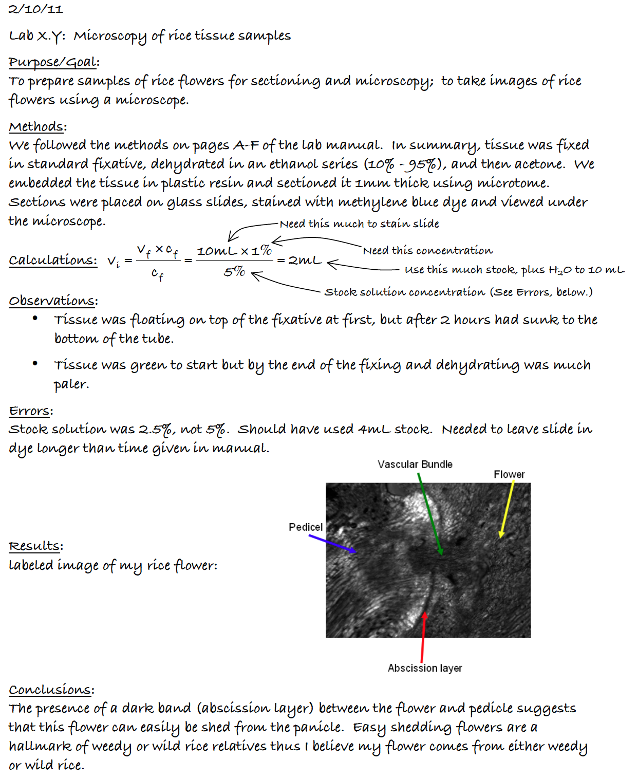

Nanodrop Blanking and Absorbance Calculations
When the NanoDrop 1000 Spectrophotometer is “blanked”, a spectrum is taken of a reference material (blank) and stored in memory as an array of light intensities by wavelength. When a measurement of a sample is taken, the intensity of light that has transmitted through the sample is recorded. The sample intensities along with the blank intensities are used to calculate the sample absorbance according to the following equation:
$$Absorbance= -log\frac{Intensity sample}{Intensity blank}$$
Thus, the measured light intensity of both the sample and of the blank are required to calculate the absorbance at a given wavelength.

Concentration Calculation (Beer’s Law)

General
The Beer-Lambert equation is used to correlate the calculated absorbance with concentration:
A = E × b × c
Where
A is the absorbance represented in absorbance units (A),
E is the wavelength-dependent molar absorptivity coefficient (or extinction coefficient) with units of liter/mol-cm,
b is the path length in cm, and
c is the analyte concentration in moles/liter or molarity (M).

Nucleic Acids
For nucleic acid quantification, the Beer-Lambert equation is modified to use an extinction coefficient with units of ngcm/mL. Using this extinction coefficient gives a manipulated equation:
$$c=\frac{A×e}{b}$$
Where
c is the nucleic acid concentration in | $$\frac{\text{ng}}{\text{μL}}$$
A is the absorbance in AU
e is the wavelength-dependent extinction coefficient in |  | $$\frac{\text{ng×cm}}{\text{μL}}$$
b is the path length in cm
The generally accepted extinction coefficients for nucleic acids are:
Double-stranded DNA: | 50 | $$\frac{\text{ng×cm}}{\text{μL}}$$
Single-stranded DNA: | 33 | $$\frac{\text{ng×cm}}{\text{μL}}$$
RNA: | 40 | $$\frac{\text{ng×cm}}{\text{μL}}$$
For the NanoDrop 1000 Spectrophotometer, path lengths of 1.0 mm and 0.2 mm are used compared to a standard spectrophotometer using a 10.0 mm path. Thus, the NanoDrop 1000 Spectrophotometer is capable of measuring samples that are 50 times more concentrated than can be measured in a standard spectrophotometer.

DNA Molecular Weight Standard
Many times in this course you will need to know the length of a fragment of DNA that you have amplified by PCR or digested with restriction enzymes, or produced by reverse transcription. This is done by loading the DNA in an agarose gel, applying a voltage, and letting the DA migrate through the gel. Shorter fragments move faster than long ones, and you can use the distance traveled during the experiment as an indicator of fragment length. In order to calibrate DNA length and distance traveled, you compare the distance your fragment traveled with the distances traveled by a series of standard fragments of known length. A DNA standard used in this course is shown in Figure 1.
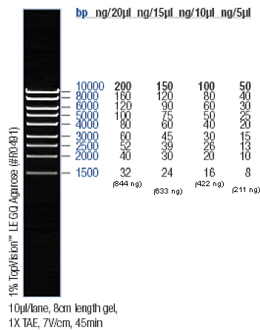
Figure 1. Fermentas #SM0393 MassRuler High Range DNA Ladder

Metric Prefixes
Prefix | Abbreviation  (note upper  and lower case) | Meaning | synonym | A sense of scale (approximate)
yotta- | (Y-) | 10²⁴ | 1 septillion | Mass of water in Pacific Ocean  Energy emitted by sun per second  Volume of earth  Mass of earth | ~1 Yg  ~400 YJ  ~1 YL  ~6000 Yg
zetta- | (Z-) | 10²¹ | 1 sextillion | Radius of Milky Way galaxy  Volume of Pacific Ocean  Annual world energy production | ~1 Zm  ~1 ZL  ~0.4 ZJ
exa- | (E-) | 10¹⁸ | 1 quintillion | Age of universe (12 billion yr) | ~0.4 Es
peta- | (P-) | 10¹⁵ | 1 quadrillion | 1 light-year | ~9.5 Pm
tera- | (T-) | 10¹² | 1 trillion | Sun-to-Jupiter distance | ~0.8 Tm
giga- | (G-) | 10⁹ | 1 billion | Human life expectancy  1 light-second | ~3 Gs  ~0.3 Gs
mega- | (M-) | 10⁶ | 1 million | Two weeks | ~1.2 Ms
kilo- | (k-) | 10³ | 1 thousand
hecto- | (h-) | 10² | 1 hundred
deka- | (da-) | 10 | 1 ten
deci- | (d-) | 10⁻¹ | 1 tenth
centi- | (c-) | 10⁻² | 1 hundredth
milli- | (m-) | 10⁻³ | 1 thousandth
micro- | (µ-) | 10⁻⁶ | 1 millionth | Diameter of human ovum  Volume of mosquito blood meal  Volume of wood frog egg | ~1 µ  ~2 µL  ~3 µL
nano- | (n-) | 10⁻⁹ | 1 billionth | Radius of chlorine atom | ~0.1 nm
pico- | (p-) | 10⁻¹² | 1 trillionth | Mass of bacterial cell | ~1 pg
femto- | (f-) | 10⁻¹⁵ | 1 quadrillionth | Radius of proton  Volume of E. coli cell  Volume of red blood cell | ~1 fm  ~1 fL  ~100 fL
atto- | (a-) | 10⁻¹⁸ | 1 quintillionth | Time for light to cross an atom  Bond energy of C=C | ~1 as  ~1 aJ
zepto- | (z-) | 10⁻²¹ | 1 sextillionth | 600 atoms or molecules | ~1 zmol
yocto- | (y-) | 10⁻²⁴ | 1 septillionth | Mass of proton or neutron | ~1.7 yg

Information and instructions taken from Thermo Scienfic’s NanoDrop 1000 Spectrophotometer V3.8 User’s Manual, http://www.nanodrop.com/library/nd-1000-v3.7-users-manual-8.5x11.pdf, accessed 1/14/13.

